App Launch Plan

For this project I developed an Inventory Management App designed for warehouse employees. This launch plan explains how the application will be introduced to users, an app description including its main features, Android capability, required permissions, monetization strategy, and the preparation for release on the Google Play Store.
The app’s Google Play Store description will focus on its main features and how it will help warehouse employees manage their inventory more efficiently. Here is the description: “The Inventory Management App is designed to help warehouse employees easily track and manage their inventory. Users can add inventory items, update quantities, and remove items that are no longer needed. The app also provides a login system to keep inventory information organized and accessible to authorized users. With a simple and easy to use interface and optional SMS notifications when items run out of stock, the app helps warehouse employees stay organized and manage inventory more efficiently.”
The app’s icon will feature a box, checklist, and settings gear. The box represents the inventory items, the checklist represents tracking stock, and the gear represents the ability to make changes to inventory. These symbols, along with the app’s name, communicate its purpose to potential users.
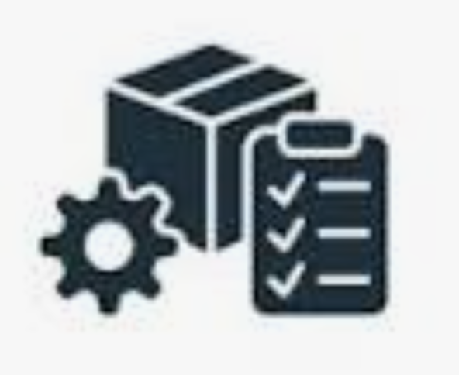

The app will be designed to support the latest version of Android while still remaining compatible with older versions. The minimum supported version will be Android 8.0 (API 26), allowing users with older Android devices to access the app. Supporting a wider range of Android versions will make the app more accessible to warehouse employees who might not have the newest devices.
The only permission the application will request is permission to send SMS messages. This permission will let the app send users a text notification when an inventory item’s quantity reaches zero. Users will have the option to grant or deny this permission. If they deny the permission to receive SMS notifications, they can still use the app’s inventory management features without any restrictions. The app will not request any other permissions that are unrelated to its functionality.
The app will use a subscription based monetization model. New users will get a 14-day free trial, allowing them to explore the app’s features before making a payment. After the trial, users can continue using the application for $5 a month. This model provides a consistent source of recurring revenue while keeping the application affordable for individuals and small businesses. The free trial allows potential customers to see whether the app meets their business needs before committing to a subscription.
Before releasing the application on the Google Play Store, I would test its functionality on different Android devices and versions to make sure the login system, inventory database, and SMS notifications are working as expected. I would also prepare the app store listing with the app’s description, icon, and screenshots showing its main features. Once testing is complete, the application would be submitted to the Google Play Store.

